Project Design Phase-II
Technology Stack (Architecture & Stack)

Date | 15-07-2026
Team ID | SWTID-2026-3345
Project Name | BookVerse – Online Book Store
Maximum Marks | 4 Marks

Technical Architecture:
The Deliverable shall include the architectural diagram as below and the information as per the table1 & table 2
Technical Architecture of BookVerse – Online Book Store
Reference: BookVerse System Architecture Details
Guidelines:
Include all the processes (As an application logic / Technology Block)
Provide infrastructural demarcation (Local / Cloud)
Indicate external interfaces (third party API’s etc.)
Indicate Data Storage components / services
Indicate interface to machine learning models (if applicable)
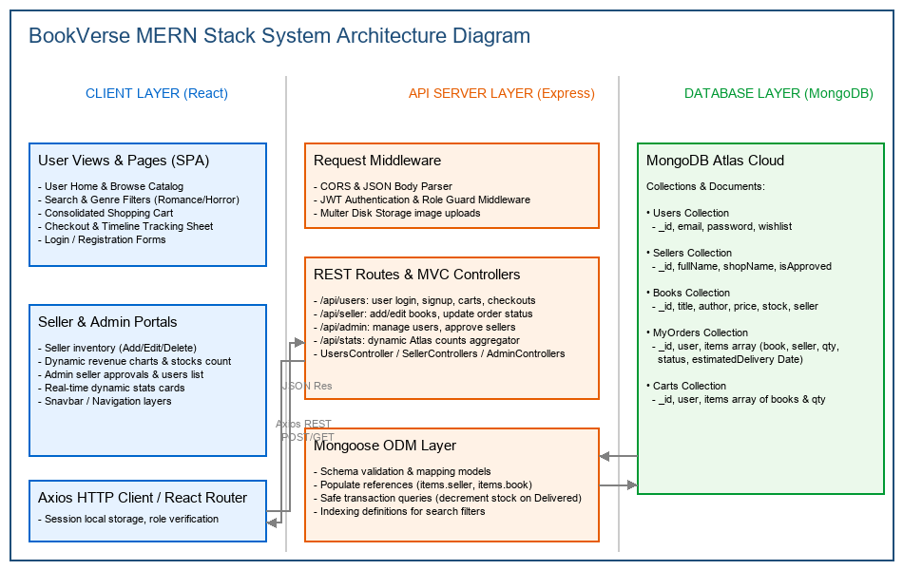

Table-1 : Components & Technologies:
S.No | Component | Description | Technology
- 1 | User Interface | How users interact with the application through frontend pages (User Home, Snavbar, Cart, Checkout timeline). | HTML, CSS, JavaScript (React.js, Vite)
- 2 | Application Routing | Client-side routing and protected path authorization guards. | React Router DOM
- 3 | Network Requests | HTTP API queries, interceptors for login handles, and JSON payloads. | Axios
- 4 | Server Middleware | CORS headers, body parsers, and role-based guards. | Node.js, Express.js
- 5 | MVC Logic - User | Handles user login, cart persistence, and order creation. | Express.js (UsersController)
- 6 | MVC Logic - Seller | Handles inventory operations, status timeline shifts, and sales revenue stats. | Express.js (SellerControllers)
- 7 | MVC Logic - Admin | Handles users and sellers listings, approval toggles, and platform stats. | Express.js (AdminControllers)
- 8 | Database Modeling | Database schema validation and relationship mapping. | Mongoose
- 9 | Token Authentication | Hashed account credentials checks and JSON Web Token verification. | bcryptjs, jsonwebtoken
- 10 | Database Storage | Document collection storage, text indexing search, and cloud clustering. | MongoDB Atlas
- 11 | Cloud Deployment | Static client page hosting, and Express web API server hosting. | Vercel, Render

Table-2: Application Characteristics:
S.No | Characteristics | Description | Technology
- 1 | Open-Source Frameworks | List the open-source libraries and frameworks used in the project. | React.js (v18), Express.js (v4), Mongoose (v8)
- 2 | Security Implementations | Role-based protected route middleware, session token authorization, and password hashing. | JWT Auth, bcryptjs
- 3 | Scalable Architecture | Decoupled database models and clean code separation. | 3-tier architecture (MERN stack)
- 4 | Availability | Database cloud storage and server hosting. | MongoDB Atlas, Render
- 5 | API Performance | Database indexes and search optimizations. | MongoDB, Mongoose

References:
https://c4model.com/
https://developer.ibm.com/patterns/online-order-processing-system-during-pandemic/
https://www.ibm.com/cloud/architecture
https://aws.amazon.com/architecture
https://medium.com/the-internal-startup/how-to-draw-useful-technical-architecture-diagrams-2d20c9fda90d

